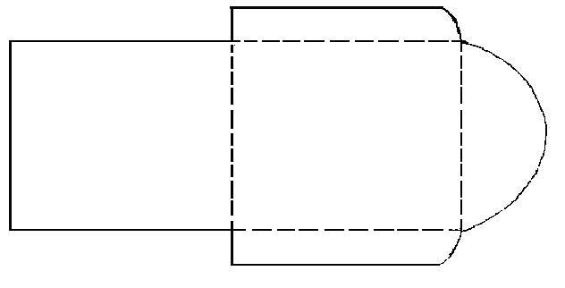


All natural candles and home products

Tina Marie Cicero
~Senior Demonstrator
412-973-0046
www.mygc.com/tinaswebsite
tinamarie.cicero@goldcanyon.com

All natural candles and home products

Tina Marie Cicero
~Senior Demonstrator
412-973-0046
www.mygc.com/tinaswebsite
tinamarie.cicero@goldcanyon.com

All natural candles and home products

Tina Marie Cicero
~Senior Demonstrator
412-973-0046
www.mygc.com/tinaswebsite
tinamarie.cicero@goldcanyon.com

Enjoy a hot cup of tea Compliments of
Tina Marie Cicero
Your Gold Canyon Demonstrator
Enjoy a hot cup of tea Compliments of
Tina Marie Cicero
Your Gold Canyon Demonstrator
Enjoy a hot cup of tea Compliments of
Tina Marie Cicero
Your Gold Canyon Demonstrator

